|  |  |  |
| --- | --- | --- |
|  |  |  |

GOVERNMENT OF INDIA

**MINISTRY OF SKILL DEVELOPMENT & ENTREPRENEURSHIP**

DIRECTORATE GENERAL OF TRAINI

**NATIONAL SKILL TRAINING INSTITUTE**

NSTI (W), Salt Lake, Kolkata-700091

**CERTIFICATE**

This is to certify that following trainees have completed their project titled

**“NSTI Smart Cloud Campus”**

**For IBM Program – IT, Networking and Cloud (Technical Diploma)**

|  |  |
| --- | --- |
| **Roll Number** | **Name** |
| ADIT19AU01323 | Sakshi Kumari |
| ADIT19AU00030 | Shreya Das |
| ADIT19AU01056 | Aditi Sau |
| ADIT19AU04163 | Shweta Roy |

|  |  |  |  |
| --- | --- | --- | --- |
| Mr. Abhishek Raman | Mr. K. L. Kuli | Mr. G. C. Ramamurthy | Mr. Sarbojit Neogi |
| IBM Faculty | ADIT Director | Principal | Section-In-Charge |

*The Project on…….*

***Architecture using Windows Server 2019***

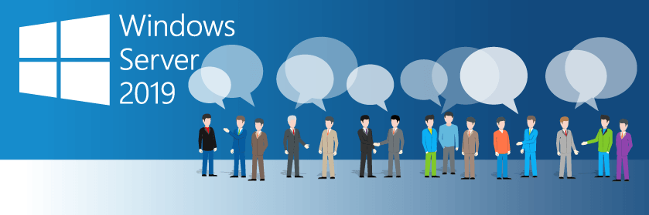

***Submitted by…….***

**SAKSHI KUMARI**

**ADITI SAU**

**SHWETA ROY**

**SHREYA DAS**

Under the supervision of

**MR. SARBOJIT NEOGI**

**(TRAINER IN-CHARGE)**

And

**MR. ABHISHEK RAMAN**

**(TRAINER OF EDUNET FOUNDATION)**

At

National Skill Training Institute (Women)

Plot x1-2&3, block-cp, Sector-v, Salt Lake,

Kolkata – 700091

March, 2021

**ACKNOWLEDGEMENT**

We would like to express our sincere gratitude to Sarbojit Neogi, Trainer In-Charge and Abhishek Raman, Trainer of Edunet Foundation, whose roles as project guide was invaluable for this project.

We are extremely thankful for their keen interest in advising us, for their unconditional help and inspiration.

Date: 28/03/2021

Index

1. Introduction Of Server
2. What is Windows Server
3. History and Latest Version
4. Windows Server 2019
5. Technology and Requirements
6. Networking Tools
7. Microsoft Windows Server 2019 Installation and Server Configuration
8. Conclusions

**Introduction of Server**

A server is a type of computer or device on a network that manages network resources. On multiprocessing operating systems, however, a single computer can execute several programs at once.

Example of Server Operating Systems are- Microsoft Windows servers, Linux / UNIX servers, NetWare, Cloud servers.

**What is Windows Server?**

Windows Server is a group of operating systems that enables a computer to handle network roles such as print server, domain controller, web server, and file server. Microsoft specifically creates it for use on a server that supports enterprise-level management, data storage, applications, and communications.

**History and Latest Version**

The Windows Server operating system was first introduced in the 1990s, and Microsoft branded it with “NT” (short for “New Technology”) up until the year 2000. The company had several releases of the NT version of the operating system, as follows: [Windows NT 3.1](https://www.dnsstuff.com/windows-server-versions-guide#windows-nt-3-1), [Windows NT 3.5](https://www.dnsstuff.com/windows-server-versions-guide#windows-nt-3-5), [Windows NT 3.51](https://www.dnsstuff.com/windows-server-versions-guide#windows-nt-3-51) and [Windows NT 4.0](https://www.dnsstuff.com/windows-server-versions-guide#windows-nt-4-0). Those versions of Windows Server have focused on stability, security, networking, and various improvements to the file system.

But starting in 2000, Microsoft began to add, after the name, the year the operating system was launched: Windows Server 2000, Windows Server 2003, Windows Server 2003 R2, Windows Server 2008, Windows Server 2008 R2, Windows Server 2012, Windows Server 2012 R2, Windows Server 2016, Windows Server 2019.

Here we discuss about Windows Server 2019.

**Windows Server 2019**

Windows Server 2019 is built on the strong foundation of Windows Server 2016 and brings numerous innovations on four key themes: Hybrid Cloud, Security, Application Platform, and Hyper-Converged Infrastructure (HCI).

**Technology and Requirements**

1. CPU speed: 133MHz (550MHz recommended),
2. RAM: 128MB (256MB recommended; 4GB maximum on Standard Server),
3. Disk space for setup: 1.5GB,
4. Monitor: Super VGA capable of providing 800 x 600 resolution,
5. Ethernet adapter, Broadband access
6. Other Device driver, Network driver, File system driver.

**Networking Tools**

Crimping Tool

****A **crimping tool** is a device used to conjoin two pieces of metal by deforming one or both of them to hold each other. The result of the tool's work is called a **crimp**.

Network cables and phone cables are created using a crimping tool to join [RJ-45](https://www.computerhope.com/jargon/r/rj45.htm) and [RJ-11](https://www.computerhope.com/jargon/r/rj11.htm) connectors to both ends of phone or [Cat 5](https://www.computerhope.com/jargon/c/cat5.htm) cable.

To use this crimping tool, each wire is first placed into the connector. Then, the connector with wires are placed into the crimping tool, and the handles are squeezed together.

Switch

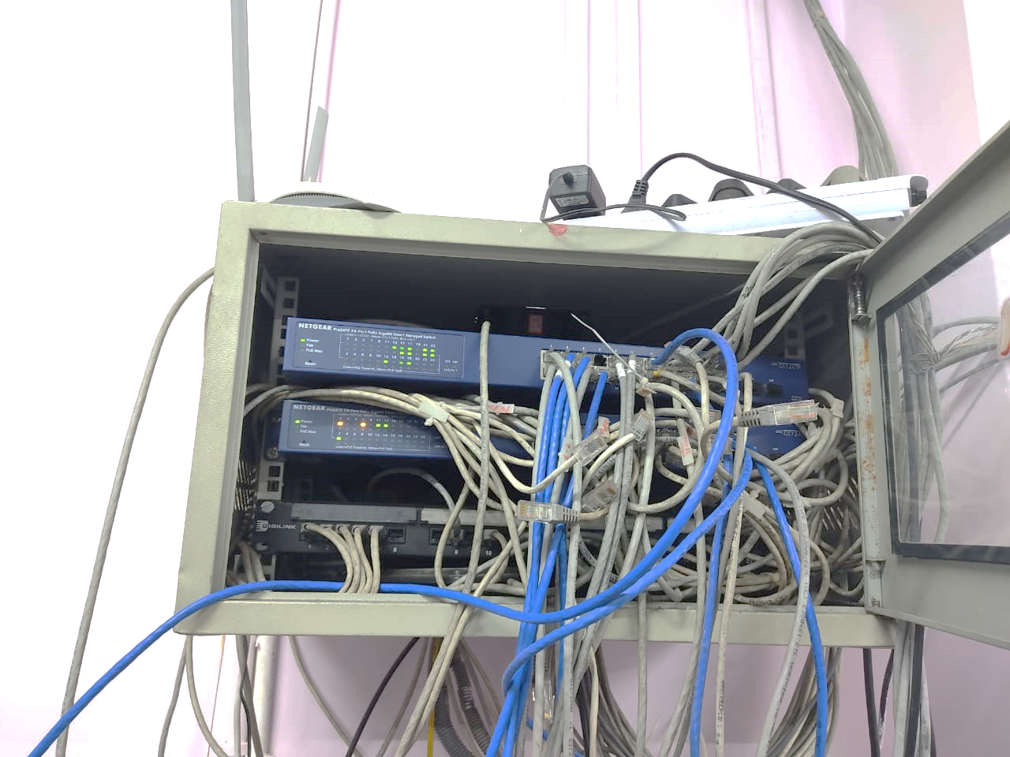Switch is a computer device that enable communication between different networked devices where multiple data cables are plugged into a switch. Switches manage the flow of data across a network by transmitting a received networkpacket only to the one or more devices for which the packet is intended. Each networked device connected to a switch can be identified by its network address (Switches are used to forward the packets based on MAC addresses.), allowing the switch to direct the flow of traffic maximizing the security and efficiency of the network. It is operated in a full duplex mode.

Types of Switches:

**1. Unmanaged switches –**

These are the switches that are mostly used in home networks and small businesses as they plug-in and instantly start doing their job and such switches do not need to be watched or configured. It allows devices on a network to connect with each other such as a computer to a computer or a computer to a printer in one location. They are the least expensive switches among all categories.

**2. Managed switches –**

These types of switches have many features like the highest levels of security, precision control and full management of the network. These are used in organizations containing a large network and can be customized to enhance the functionality of a certain network. They are achieved by setting a simple network management protocol (SNMP).

Networking Cables

Networking cables are used to connect one network device to other network devices or to connect two or more computers to share [printers](https://en.wikipedia.org/wiki/Printer_(computing)), [scanners](https://en.wikipedia.org/wiki/Image_scanner) etc.

Different types of network cables, such as [coaxial cable](https://en.wikipedia.org/wiki/Coaxial_cable), [optical fiber cable](https://en.wikipedia.org/wiki/Optical_fiber_cable), and [twisted pair](https://en.wikipedia.org/wiki/Twisted_pair) cables, are used depending on the network's [physical layer](https://en.wikipedia.org/wiki/Physical_layer), [topology](https://en.wikipedia.org/wiki/Network_topology), and size. The devices can be separated by a few meters (e.g. [Ethernet](https://en.wikipedia.org/wiki/Ethernet)) or nearly unlimited distances (e.g. the interconnections of the [Internet](https://en.wikipedia.org/wiki/Internet)).

**Twisted pair:-**

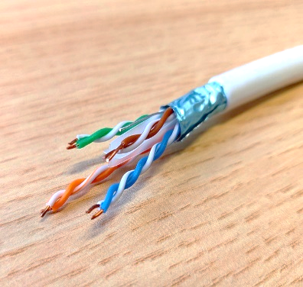Twisted pair cabling is a form of wiring in which pairs of wires (the forward and return conductors of a single [circuit](https://en.wikipedia.org/wiki/Electronic_circuit)) are twisted together for the purposes of canceling out [electromagnetic interference](https://en.wikipedia.org/wiki/Electromagnetic_interference) (EMI) from other wire pairs and from external sources. This type of cable is used for home and corporate [Ethernet](https://en.wikipedia.org/wiki/Ethernet) networks. Twisted pair cabling is used in short [patch cables](https://en.wikipedia.org/wiki/Patch_cable) and in the longer runs in [structured cabling](https://en.wikipedia.org/wiki/Structured_cabling). There are two types of cable**:-**

**1) Unshielded Twisted Pair (UTP) Cable.**

**2) Shielded Twisted Pair (STP) Cable.**

**Coaxial:-**

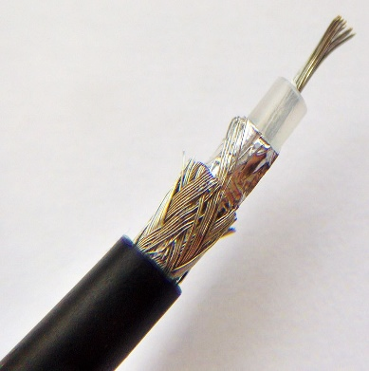Coaxial cable form a [transmission line](https://en.wikipedia.org/wiki/Transmission_line) and confine the electromagnetic wave inside the cable between the center conductor and the shield. The transmission of energy in the line occurs totally through the dielectric inside the cable between the conductors. Coaxial lines can therefore be bent and twisted (subject to limits) without negative effects, and they can be strapped to conductive supports without inducing unwanted currents in them.

Coaxial cables are commonly used for television and other broadband signals. Although in most homes coaxial cables have been installed for transmission of [TV](https://en.wikipedia.org/wiki/TV) signals, new technologies (such as the [ITU-T](https://en.wikipedia.org/wiki/ITU-T) [G.hn](https://en.wikipedia.org/wiki/G.hn) standard) open the possibility of using home coaxial cable for high-speed [home networking](https://en.wikipedia.org/wiki/Home_network) applications.

**Fiber Optic:-**

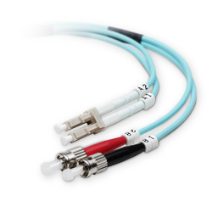An [optical fiber cable](https://en.wikipedia.org/wiki/Optical_fiber_cable) consists of a center glass core surrounded by several layers of protective material. Optical fiber deployment is more expensive than copper but offers higher bandwidth and can cover longer distances. There are two major types of optical fiber cables: shorter-range [multi-mode fiber](https://en.wikipedia.org/wiki/Multi-mode_fiber) and long-range [single-mode fiber](https://en.wikipedia.org/wiki/Single-mode_fiber).

**Microsoft Windows Server 2019 Installation and Server Configuration**

At first, boot the Windows Server 2019 setup file and select the language, time and currency format and keyboard type

**Press the ‘install now’ button to install the Windows Server 2019 operating system**

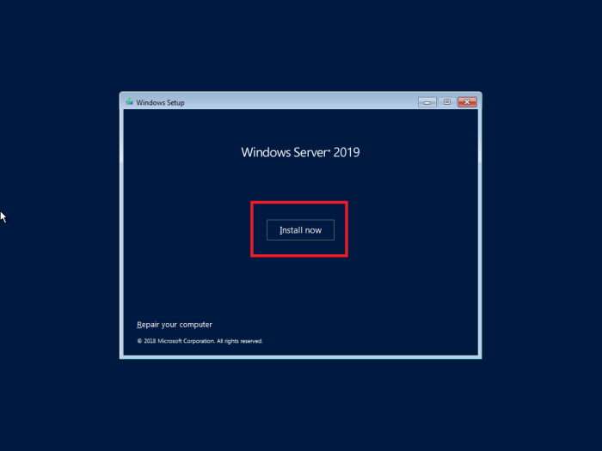

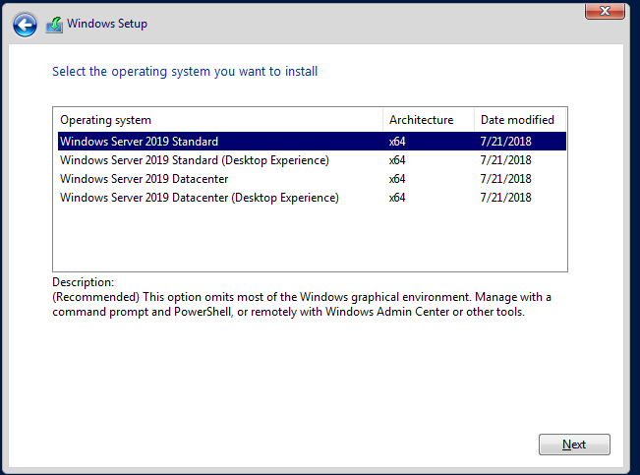**Tick to confirm that you accept the license terms and after tick mark select the operating system you want to install,**

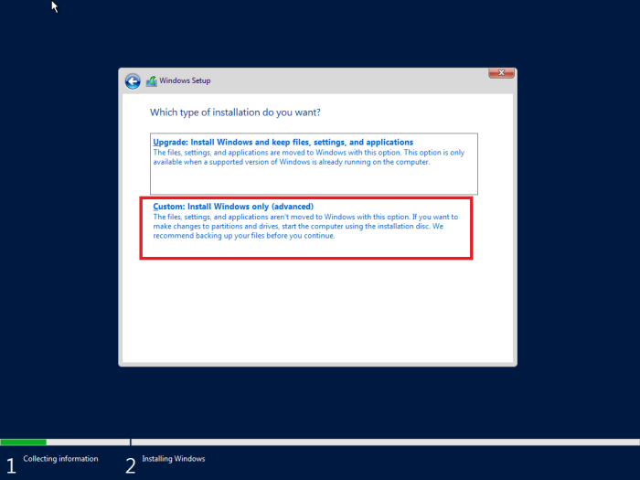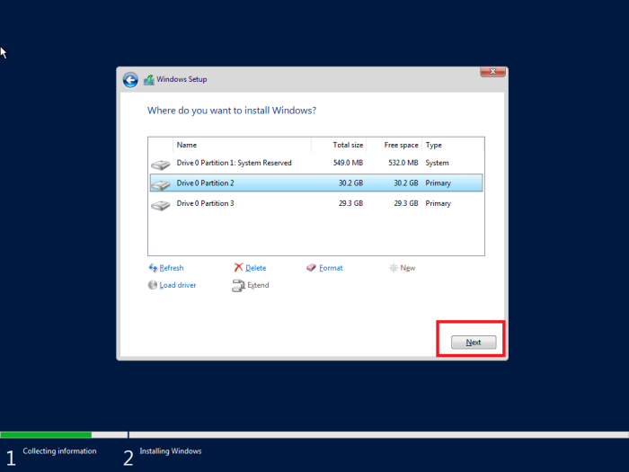**Choose the custom installation option and after that create and choose a new partition to install Windows Server 2019**.

**After portioning it takes some time so, wait until the installation finishes.**

**Then restart the machine to complete the installation .(If you want you can force restart by pressing ‘restart now’ or wait till the timer is finished).**

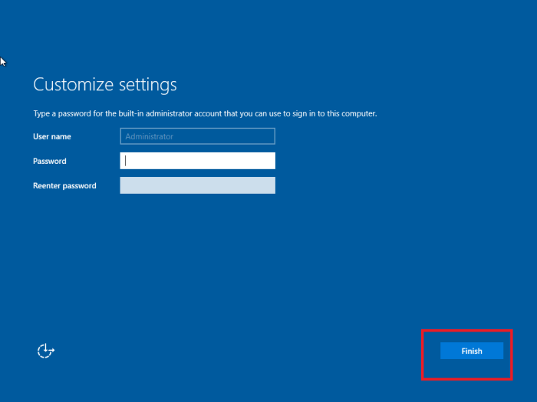**After the restart you have to provide a password to the local ‘Administrator’ account**.

**Enter the previously given password to login as the administrator. The Microsoft Windows Server 2019 installed successfully**.

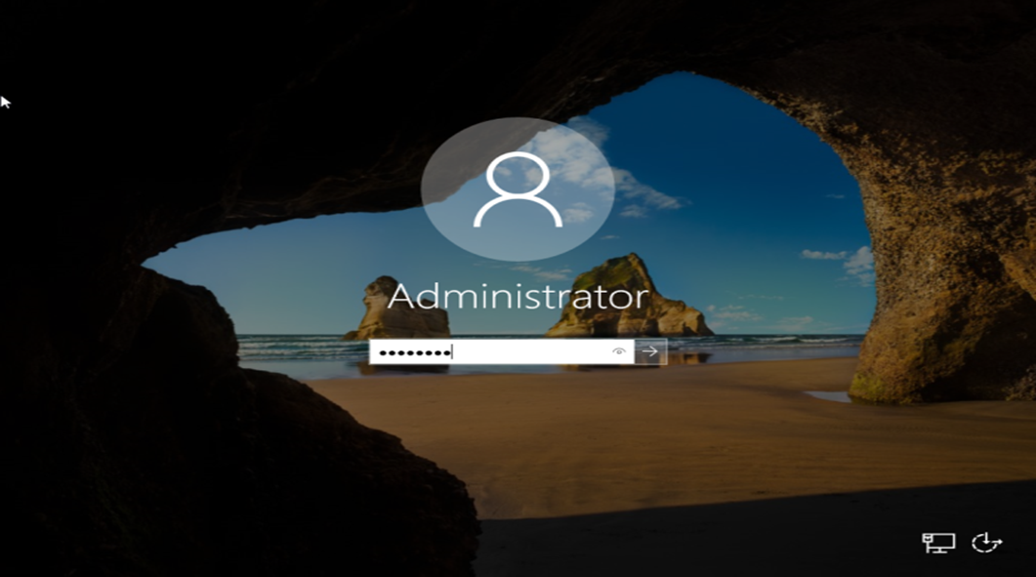

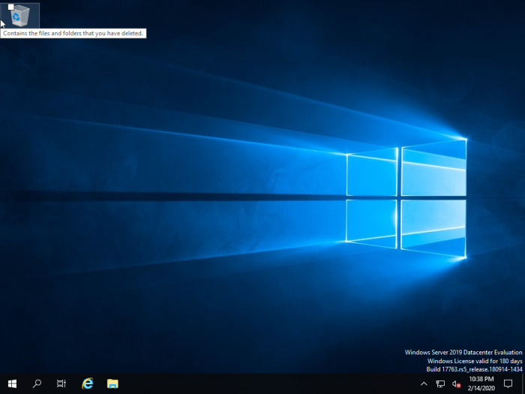**Press ‘Start’ button to explore the Windows Server 2019 options**.

# **Install and Configure DHCP Server on Windows Server 2019**

Having a DHCP Server in your organization can really make your network management a breeze. Instead of assigning IP addresses manually on every machine in your organization, let a DHCP Server do this task that can get quite boring and unnecessarily repetitive.

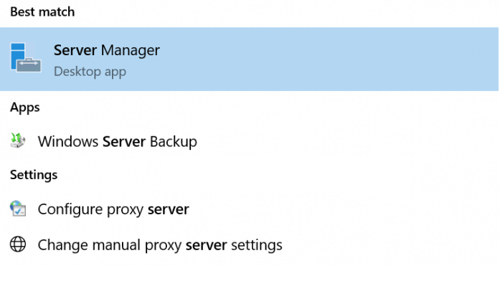The first step is to open up “**Server Manager**” so that we can start the installation process. Hit your “**Windows**” button and type in “**Server Manager**” and choose the app that brings itself up.

On your “**Server Manager**” window, click on “**Add Roles and Features**“. This will bring up a pop-up window. Click “**Next**” on that pop-up.

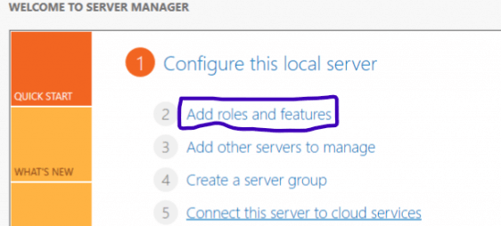

Choose the “**Role Based or Feature based installation**” radio option and hit “**Next**“.

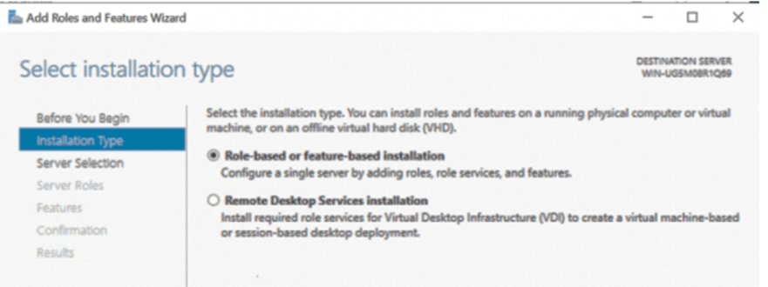

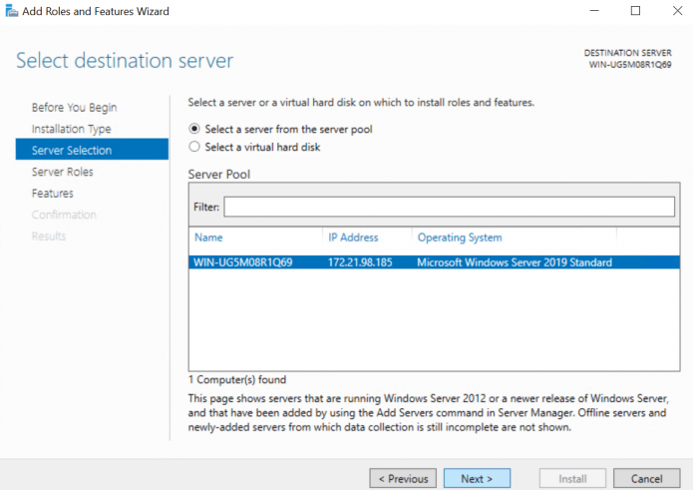

**This next page is titled** “**Select Server Roles**” **and has got a list of roles to install. As you can guess, we are** **going to choose** “**DHCP Server**“.

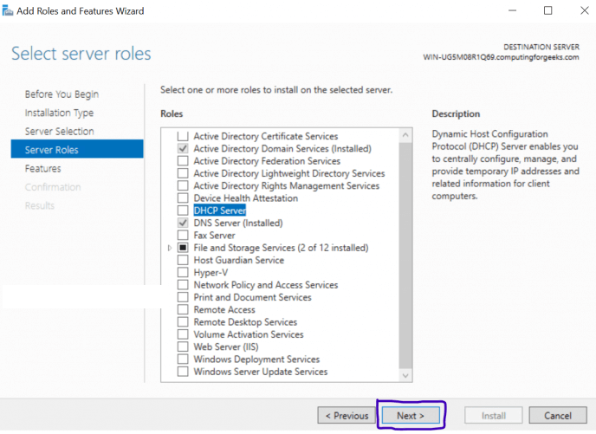

**After you choose “DHCP Server” on the previous step, another pop-up window will come up titled “Add features that are required for DHCP Server? “. Simply click on “Add Features“. Click on “Next” after that.**

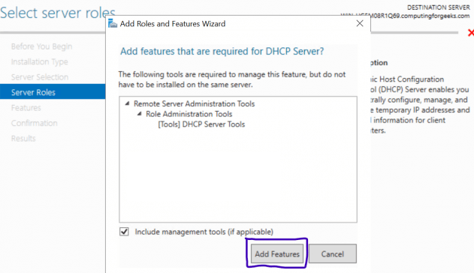

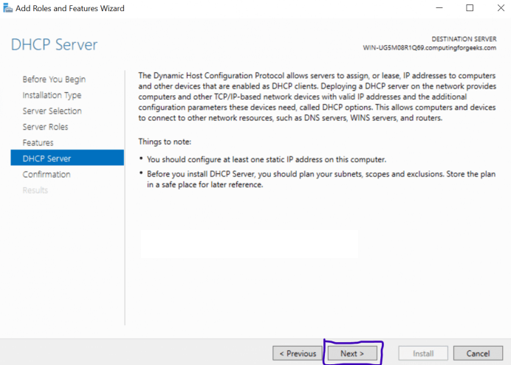

**The next page is titled “Confirm installation selections“. Look at the list provided and confirm that DHCP Server and others are listed. After that, click “Install“. After everything is successfully installed, click “Close” and your DHCP Server is installed. Let us proceed to do Post-deployment Configuration on the DHCP.**

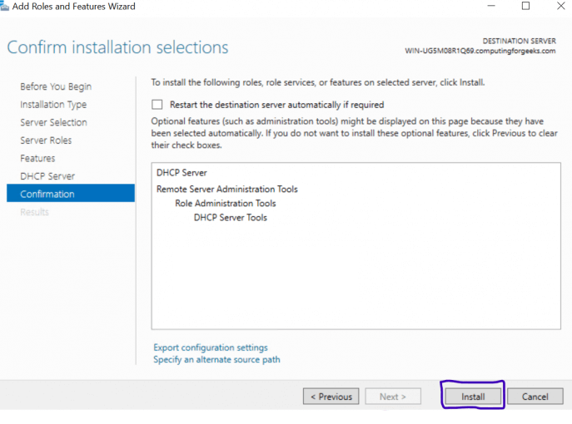

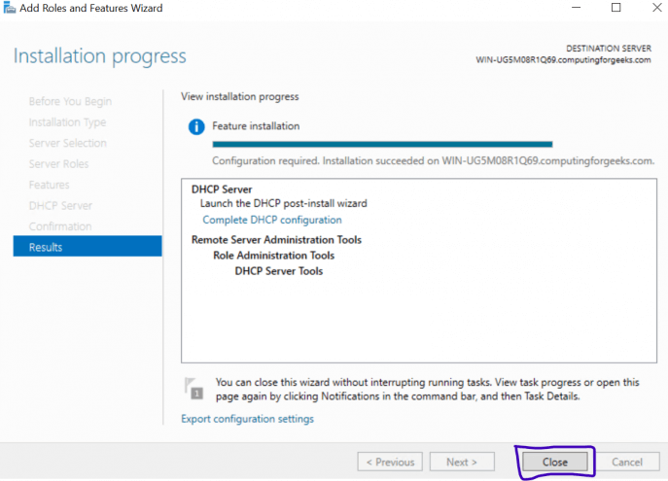

**After that click on “Complete DHCP Configuration” at the end of that line as shown below. An installation wizard will come up. Click “Next”. Go back to Server Manager, click on “Tools” and choose “DHCP“. This will open DHCP Configuration Window.**

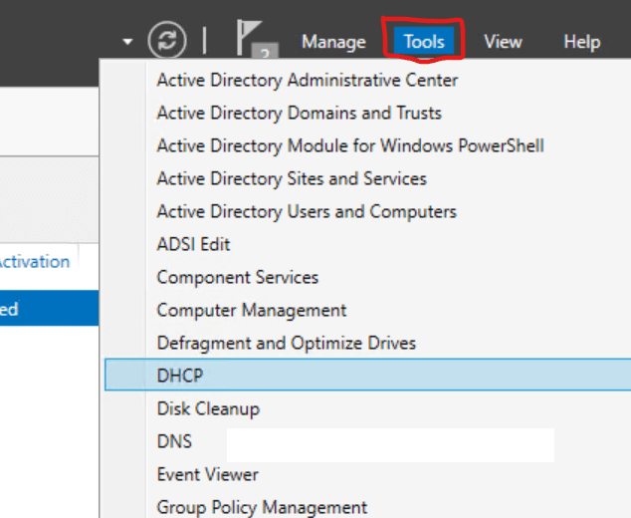

**On the left pane of the window, click the drop-down as shown above and right-click “IPv4” then choose “New Scope“.Put in a name and Description of this new scope. Input your start and IPs, Length and Subnet Mask. Lease duration is the time DHCP Server will give a specific computer or client an IP before changing it or giving it another one when it logs-in again.**

**The DNS is very important because it will facilitate the resolution of FQDN to IP Addresses.**

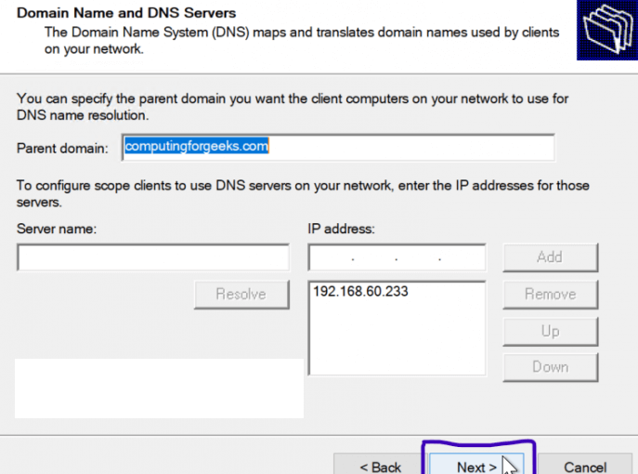

**After activated the scope we have finally finished our DHCP Server Configuration**.

# **Install Active Directory Domain Services in Windows Server 2019**

One of the best features that make Windows server to shine in the Enterprise sphere is Active Directory. This single Sign-on product that seamlessly and easily integrates with most of Microsoft products makes user management among other tasks quite easy and fun. This guide is about how to install Active Directory Domain Services on a newly installed Windows server 2019.

**The installation process are quite same as DHCP Server installation**.

After finished installing Active Directory Domain Services, the last step is to promote it to a Domain Controller. Go over to Server Manager where you will notice a yellow exclamation notification beside the “**Manage**” tab as shown below. Click on it and choose “**Promote this server to a domain controller**“

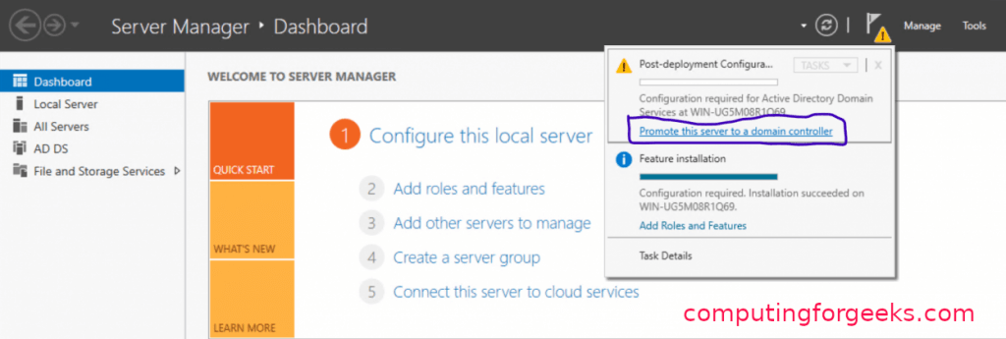

A new window titled “**Active Directory Domain Services Configuration Wizard**” as shown below will pop up. We are going to **add a new Forest** but in case you would wish to do something different in this Step, you are free to choose the other options. Add your organization’s root domain name. Click on “**Next**” after you pick your choice.

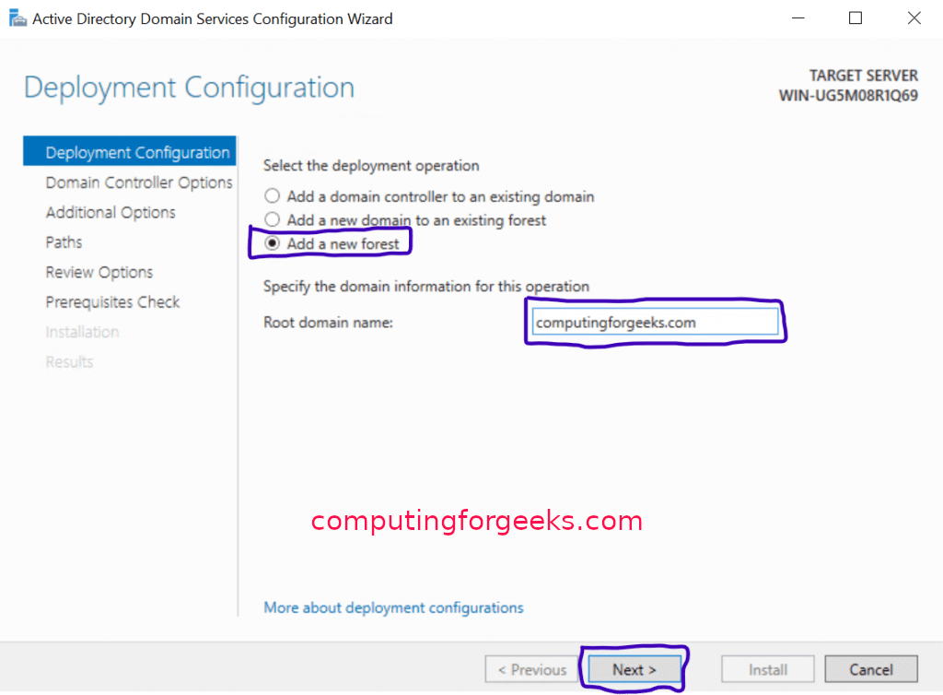

On the Domain Controller options, leave the defaults checked and input your password. After that, click “**Next**“.

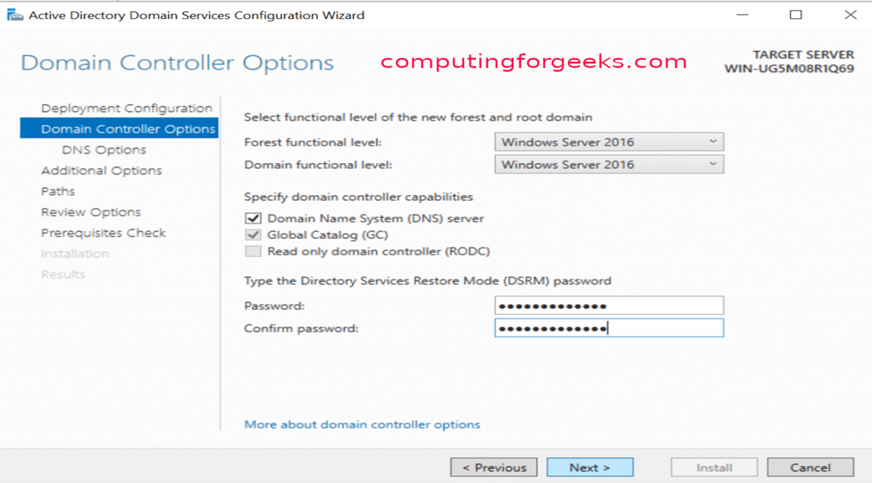

After that “A delegation for this DNS server cannot be created because the authoritative parent zone name server cannot be found “is coming. Ignore it and click “**Next**“. On the next page, leave the NetBIOS domain name as default or you can change it as long as it is not longer than 15 characters. Click “Next” after that. Leave paths as default and click “Next”. Prerequisites Check will be validated before Active Directory Domain Services is installed. If you get any errors here, please look at it and fix anything in the previous steps. If all is okay, click “**Install**“.

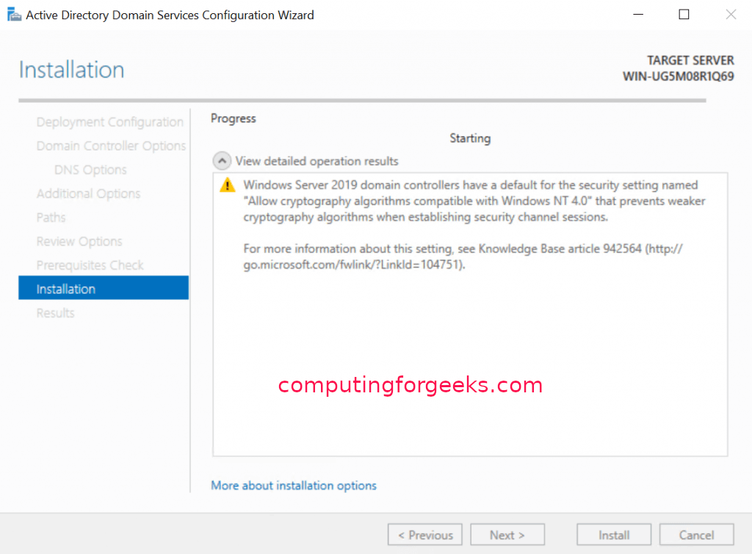

Now user have Active Directory Domain Services Installed and can be managed by Active Directory Administrative Center.

**Conclusion:**

Windows server is a line of Operating system that Microsoft especially creates for use on a server. Basically windows server is used in business setting. Its include plenty of enterprise software. Active Directory (AD) is a user management service provided by window server that acts as domain controller. DHCP (Domain Host Controller Protocol) is a protocol that lets window server automatically assign IP address on the network.

Here in NSTI (W), windows server is used to configure the systems of the IBM lab. Windows Operating System has been already installed in all the systems. And we are already familiar with the user interface of the windows. So it was very easy for us to configure all the systems through window server in our lab.